|  |  |  |
| --- | --- | --- |
|  |  |  |
|  |  | News from Nuclear Slovenia  March 2025 |
|  |  |  |

Brief Summary

In the reporting period from October 2024 to March 2025, all nuclear installations in Slovenia have been operating safely and without any significant safety events. The causes for the leak in the primary cooling system of the Krško Nuclear Power Plant (NPP) were identified, but corrective actions are still under investigation. The construction of the low- and intermediate level radioactive waste (LILW) repository is progressing according to the time plan. The activities on the project for the construction of a new Slovenian power plant are still ongoing.

The Slovenian Nuclear Safety Administration (SNSA) continues to maintain good bilateral relations with foreign regulatory bodies and ensures the regular staff training in emergency preparedness. Furthermore, the Slovenian Early Warning System for monitoring radiation levels is being renewed and modernized.

|  |
| --- |
|  |

# The Krško NPP

## Unplanned shutdown due to primary coolant leakage - follow-up: DCA/RCA analysis

An unidentified leak in the primary system was detected on October 4, 2023. As a precaution, the plant was shut down. A leak found was caused by a crack on the weld of the direct reactor vessel injection pipeline SI-53. The Krško NPP approached the repair of the detected leak in a conservative way and in accordance with its programmes. A decision was made to replace SI-53 line and the sister line SI-52 line between the safe end of the reactor vessel and the first isolation valve of each line. Additional temperature sensors, strain gauges and LVDT (linear variable displacement transformer) displacement sensors were installed on the new SI-53 line.

Segments of the SI-52 and SI-53 pipelines were sent to the USA, where mechanical tests and metallographic analyses of the stainless steel base material, the weld seam and the crack were carried out in the Westinghouse hot-cell laboratory. Data from laboratory tests, LVDT sensors, strain gauges and temperature measurements during NPP operation, as well as computer analyses performed, were used to prepare a root cause analysis report for a discovered SI-53 leak.

Westinghouse and Ansaldo performed thermal-hydraulic and mechanical analyses. Technical support organisations: the Jožef Stefan Institute, the Faculty of Mechanical Engineering in Ljubljana and the Faculty of Electrical Engineering and Computer Science from Zagreb also conducted several independent reviews of the thermal-hydraulic and mechanical analyses.

The Westinghouse root cause analysis report states that the root cause of the SI-53 leakage is determined to be a design deficiency of the safety injection pipeline into the reactor vessel with excessive thermal stratification caused by low-flow safety injection transients and low amplitude – high cycles transients (in-out water flow from the reactor vessel) or so called thermal fatigue. Contributing factors which might have been present include installation deficiency which may have contributed to cold spring appearance in the pipe and the fact that weld with a crack was not being subject to in-service inspections (ISI), as the potential for thermal stratification and cycling was not known.

Based on the root cause analysis report, an action plan was drawn up to minimize the effects of thermal stratification. The Krško NPP will:

* continue to monitor pipe temperatures and displacements to obtain real/detailed data for comparison with analytical models,
* Include the butt welds of the SI-53 and SI-52 lines in the ISI program for the pipelines with ultrasonic inspection at least every 5 years, with additional visual inspection from inner side shell at the end of each inspection interval,
* analyse the impact of additional thermal insulation considering low SI flow causing significant thermal stratification,
* installation of additional thermal insulation to reduce the flow of medium from/to the reactor vessel based on the results of the analysis,
* analysis of the effects of additional thermal insulation considering a low SI flow rate causing significant thermal stratification.

# The JEK2 project - New Nuclear Power Plant in Slovenia

The Government of the Republic of Slovenia continues to be active in the JEK2 project through a dedicated State Secretary to the Prime Minister’s cabinet that is responsible for coordination of different ministries and administrations, including the SNSA, in preparation for the JEK2 project and the processes of licensing.

The project is progressing with the preparation of studies and other documentation to support the development of the National Spatial Plan and the necessary updates to local infrastructure. The preparation process for the National Spatial Plan is scheduled to begin in 2025. On 15 October 2024, the amended initiative for the National Spatial Plan was submitted by the investor, GEN Energija, to the Ministry of the Environment, Climate, and Energy (MECE). Following a thorough review, the MECE confirmed that the initiative aligns with the appropriate national strategies and complies with relevant legislation. As a result, the MECE approved the initiative and forwarded it to the Ministry of Natural Resources and Spatial Planning (MNRSP), which is responsible for strategic spatial planning. The MNRSP began reviewing the contents of the initiative, requesting further clarification and several amendments. The SNSA, as a regulatory body within the MNRSP, was involved in the review process and provided comments on nuclear and radiation safety.

Simultaneously, GEN energija started to prepare a Technical Feasibility Study (TFS), where two NPP vendors will participate, the EDF and Westinghouse. The TFS shall be completed in late 2025. The third NPP vendor KHNP will not participate in the JEK2 project anymore.

The SNSA continues with preparation of new legislation and guidelines for the new builds. The *Decree on the areas of limited use of space due to a nuclear facility and the conditions of facility construction in these areas* is in revision. The *Practical guideline on contents of the Safety analysis report* will be updated and a new *practical guideline on defining the siting process for new nuclear facilities* shall be issued in 2025.

# Radioactive Waste Management

## Construction of the repository for low and intermediate level waste

The construction of the LILW repository in Vrbina, in the municipality of Krško, is progressing according to plan. By the end of 2024, the installation of the primary wall of the silo was completed. The construction of relief wells was also concluded at the beginning of 2025. This will be followed by soil excavation and the beginning of the construction of the secondary wall of the silo.

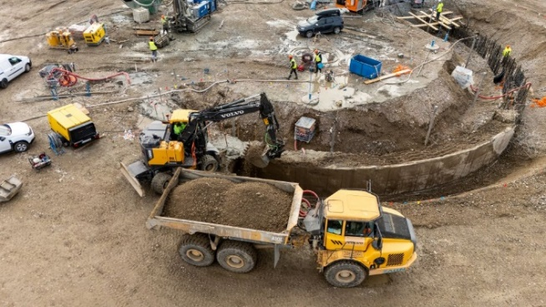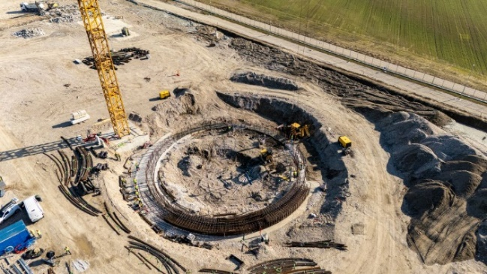

Figure 1 and 2: Demobilization of the contractor's equipment for the primary silo wall and construction of reinforcement connections of the reinforced concrete ring of the silo. Author: ARAO.

# International Cooperation

## U.S. Nuclear Regulatory Commission visits SNSA

As part of efforts to strengthen international cooperation in the field of nuclear safety, a delegation from the U.S. Nuclear Regulatory Commission (NRC), led by Commissioner David A. Wright, visited Slovenia on 6 and 7 November 2024. The delegation met with the SNSA management, and the main topics of discussion focused on enhancing cooperation between the SNSA and the NRC, particularly in the area of training new personnel for the SNSA in nuclear safety and inspection. During the visit, the NRC delegation, accompanied by the SNSA, also visited the Krško NPP. The visit of the U.S. delegation confirmed the strong cooperation between Slovenia and the U.S. in the field of nuclear safety and conducting regulatory oversight of the Krško NPP, while opening up new opportunities to further strengthen this collaboration.

## Strong Bilateral Relations with Croatia Continue

The annual meeting, held in accordance with the bilateral agreement between the Republic of Slovenia and the Republic of Croatia on the early exchange of information in the event of a radiological emergency, took place on 19 December 2024 in Ljubljana. Participants discussed recent developments in legislation and regulatory infrastructure, emergency preparedness, and implementation of radiological monitoring. They also shared information and experience related to ongoing projects on radioactive waste storage, as well as capacity building and human resource management. Both countries reaffirmed their strong cooperation and emphasized the importance of swift, transparent exchange of data, information, and expertise in all areas of nuclear safety and radiation protection.

# Emergency Preparedness

## Early Warning System for Radiation in the Environment

In the event of a nuclear or radiological accident in Slovenia or abroad, one of the Slovenian SNSA's key responsibilities is to provide immediate data on environmental radioactivity. This information is crucial for implementing effective protective measures for the population.

Following the Chernobyl disaster, Slovenia established the Slovenian Early Warning System (EWS) to monitor radiation levels. All collected radioactivity data is automatically imported into the *Radioactivity in the Environment* application ([RVO](http://www.radioaktivnost.si/)), which is accessible to both the public and SNSA staff (Figure 3). RVO provides real-time dose-rate data, radiation measurements, and other relevant information. Additionally, it supports two-way communication with mobile units and enables real-time data transfer from vehicle-based monitoring systems.

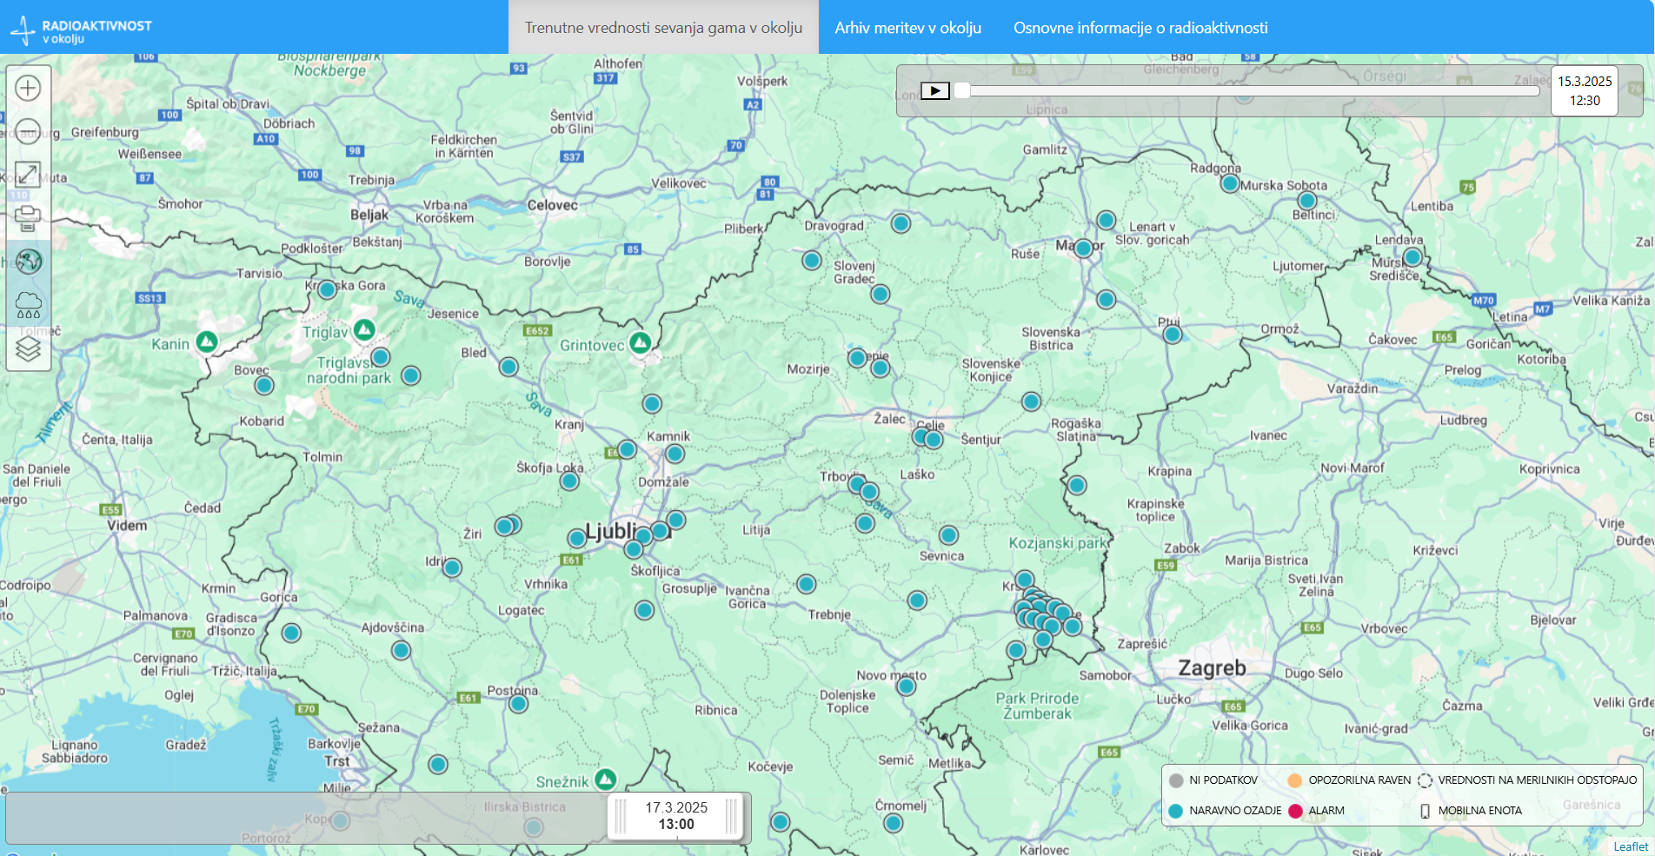

Figure ­3: Basic overview of the status of the early warning network in Slovenia.

Since 2017, the SNSA has been carrying out a large-scale renewal of the EWS to modernize all its components, including data collection and display software, communication channels, and measuring devices.

Between 2021 and 2023, the SNSA successfully secured funding from the Ministry of Environment and Spatial Planning to purchase 54 Envinet MIRA devices. Additionally, 10 more devices were acquired through donations from the International Atomic Energy Agency, bringing the total number of new devices to 64. By the end of 2024, the intensive installation of these devices was successfully completed at all existing locations, with four new sites added in the process. The new Envinet MIRA devices offer several key advantages, including enhanced sensitivity for faster data collection and alarm activation, automatic communication initiation, redundant power sources (electrical mains, battery, and solar panel), redundant communication channels, and an automatic restart function after 24 hours of outage. Additionally, a project was completed to connect these devices to electrical and communication networks where possible, ensuring improved autonomy and more reliable data transmission.

To provide easy and fast access to all relevant data, 14 older MFM dose rate meters - owned by nuclear facilities - were also integrated into the EWS. These include 13 devices near the Krško NPP and one at the TRIGA Research Reactor. The upgraded dose rate meters significantly enhance the speed and accuracy of radiation assessments in the event of a possible accident. Furthermore, the expansion of the network with four additional monitoring locations has improved Slovenia’s overall radiation monitoring coverage.

## EPR Exercises and Trainings

At the end of 2024, the SNSA conducted an analysis of the effectiveness of our emergency response training programs, the results were highly satisfactory. In 2024, a total of 134 individual and group training sessions, drills, and exercises were carried out, amounting to 2,490.5 man-hours. This accounted for 98% of all planned training activities.

In early 2025, alongside regular training, two key workshops were held: a workshop on Crisis Communication for Leaders in January, and the National Workshop on Public Communication in March. Public Communication workshop focused on the importance of clear, timely, and accurate communication during nuclear or radiological emergencies. Participants from key institutions involved in public communication in such events - including representatives from the Krško NPP, the Administration for Civil Protection and Disaster Relief, the Agency for Radioactive Waste Management, the National Institute of Public Health, the Slovenian Radiation Protection Administration, and the SNSA - gained valuable insights into crisis communication strategies, misinformation management, and the psychological aspects of public response.Similar to the first workshop, the crisis communication session proved to be highly impactful. A well-tailored case study, complemented by a structured presentation, helped identify areas for improvement in SNSA's proactive public communication, while productive valuable discussions contributed to enhancing our future crisis response strategies.

|  |
| --- |
| Prepared by:  **Slovenian Nuclear Safety Administration**  Litostrojska cesta 54  1000 Ljubljana, Slovenia  Telephone: +3861/472 11 00  Fax: +3861/472 11 99  E-mail: [gp.ursjv@gov.si](mailto:gp.ursjv@gov.si)  URL: [www.ursjv.gov.si/en](http://www.ursjv.gov.si/en)  Ljubljana, March 2025 |