# BRIEF SUMMARY

In the reporting period from April to October 2024, all nuclear installations in Slovenia have been operating safely and without any significant safety events. The Krško Nuclear Power Plant (NPP) regular outage was successfully completed. The construction of the repository for low- and intermediate-level waste is in progress and preparation activities on the project for the construction of a new Slovenian power plant are also moving forward. The most important nuclear safety regulations and Rules on the management of radioactive waste and spent fuel entered into force.

The Slovenian Nuclear Safety Administration (SNSA) continues to maintain good bilateral relations with foreign regulatory bodies and also hosts important international events. The SNSA regularly monitors the status of nuclear installations in Ukraine, participates in relevant emergency exercises and regularly updates emergency procedures.

# GENERAL NEWS AND LEGAL SYSTEM

## New Rules on radiation and nuclear safety factors

New *Rules on radiation and nuclear safety factors* were adopted at the end of June 2024 and entered into force on 24 July. These Rules align with the key standards set by the International Atomic Energy Agency (IAEA) and incorporate the latest requirements from the Western European Nuclear Regulators Association (WENRA Safety Reference Levels - SLR of 2020). They also reflect the recommendations from the IAEA's Integrated Regulatory Review Service (IRRS) mission which assessed the legislative and regulatory framework for nuclear and radiation safety in April 2022, as well as the European Directive on Nuclear Safety.

The changes primarily focus on the design bases, the content of the application for a licence to store or treat radioactive waste for the purposes of the compulsory national public service for radioactive waste management and the design requirements for human factors and human-machine interface. Additionally, the requirements for cyber security of nuclear installations, the management system, and the design bases for nuclear power plants, irradiation facilities or particle accelerators were updated. Design requirements for internal hazards and for external hazards due to human activities were added based on WENRA SRL Issues SV (internal hazards) and TU (external hazards).

## New Rules on the safety assurance of radiation and nuclear facilities

New *Rules on the safety assurance of radiation and nuclear facilities* were adopted in March 2024 and entered into force on 13 April. The changes concern the new chapters on management and control of facility systems, special requirements for core and fuel in nuclear power plants and research reactors and other programmes aligned with the requirements of the IAEA Standards. A revised Emergency Preparedness chapter aligns with the *Rules on the content and preparation of protection and rescue plans*. In addition, the requirements for reporting of a nuclear power plant and for annual reporting of a research reactor were updated. The requirements for the ageing management and technological obsolescence have been updated based on the more recent WENRA reference levels. Furthermore, the related recommendations of the 2022 IRRS mission were implemented in the new Rules.

## Amended Rules on Radioactive Waste and Spent Fuel Management

In August 2024, an amendment to the *Rules on the management of radioactive waste and spent fuel* entered into force. The main objective of the amendment is to supplement the requirements for the storage of radioactive waste. It is now possible to temporarily store radioactive waste on the external surfaces of the nuclear facility site, i.e. radioactive waste that is ready for further handling outside the nuclear facility site. This is a solution which, due to the lengthy approval procedures for the shipment of radioactive waste for treatment abroad (including all transit countries and the country of destination), requires interim storage of finished transport containers with radioactive waste on site until the transport is approved. The interim storage of freshly filled disposal containers is also resolved: those will have to be held separately for a certain period until being emplaced in the repository in order to obtain the appropriate strength and properties for further handling and to meet the disposal conditions. The period for the described storage is set at 18 months.

# THE KRŠKO NPP

## Regular outage

The Krško NPP outage after the 33th fuel cycle started on 1 April 2024 and finished on 2 May when the generator was reconnected to the power grid. This was the first outage in the extended operating period of the Krško NPP. Besides the regular activities, such as refuelling and reactor physics tests with preventive inspections, maintenance works, and surveillance tests, 14 modifications were implemented during the outage. Some of the more important modifications were the replacements of the motor generator sets’ control and protection cabinets, of the component cooling system heat exchanger, of the ultrasonic level measurement system on reactor coolant system loop 1, the implementation of protection against one phase failure, the replacement of the secondary equipment on 110 kV and 400 kV switchyard, upgrade of the control system on two transformers and work on the high-pressure steam turbine. Some of the major maintenance activities were the overhauls of the connecting valve on the component cooling system, of the motor-driven auxiliary feedwater system pump, of the main electric generator, of the laser scan of the reactor vessel flange surface, the replacement of the incore guide tubes, the eddy current testing of steam generators tubes, and the sludge lancing of steam generator tube bundles.

The In-Service Inspection plan for the outage consisted of a regular component inspection scope and an additional inspection scope (One-Time Inspection), as decided by the NPP to follow up on the discovered leak on the SI-53 pipeline in October 2023. The additional inspection covered the ultrasonic testing of 40 locations (welds) on the safety injection, the residual heat removal system, the control volume system and the reactor coolant system pipelines.

The next outage of the Krško NPP is scheduled for the autumn of 2025.

# RADIOACTIVE WASTE MANAGEMENT

## Start of Construction of the Repository for Low- and Intermediate-level Waste

The construction permit for the disposal part of the repository for low- and intermediate-level waste (LILW) was granted in July 2022 and has been legally binding since 2023. The construction permit for the repository's infrastructure facilities was also granted in the same year.

The infrastructure work on the construction site of the LILW repository was completed in May 2024. The ARAO - Agency for Radioactive Waste (ARAO) began work in August last year and, as part of the infrastructure measures, carried out the reconstruction of the access road to the repository construction site with footpaths, a cycle path with corresponding connections and public lighting, as well as the installation of water, telecommunications and electricity supplies. ARAO also provided physical protection for the nuclear facility.

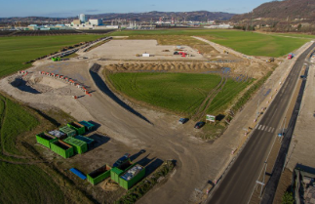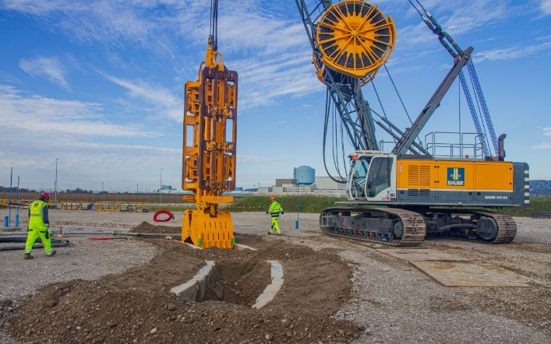

Figure 1: Construction site of the LILW repository and the start of excavation for the disposal wall (diaphragm). Author: ARAO

At the construction site of the LILW repository, ARAO began excavating the opening for the construction of the retaining wall of the repository silo (diaphragm wall). The inlet is designed as a reinforced concrete wall, which will be a guide for the excavation machine of the retaining wall of the repository silo and is as such a temporary construction. The area is also being prepared for the contractor to assemble the retaining wall of the disposal silo. The construction of the nuclear part will include the construction of a technological and administrative service facility, the construction of a disposal silo, a hall above the silo and the installation of a lifting platform. The contract for the delivery of the portal elevator was signed in October 2024 with the company Riko d.o.o. from Ljubljana and the Spanish subcontractor Taim Weser. The delivery and installation of the elevator is scheduled for 2027.

In 2024, 2025 and 2026, the construction of an administrative and service facility, the construction of the repository silo retaining wall (diaphragm), the excavation of the repository silo and the execution of all concrete works inside the repository silo, including the stairs, are planned. Foundations are also planned for the start of assembly of the repository hall. The construction of the technical facility will take place in 2025 and 2026.

The construction of the hall above the silo and the delivery and assembly of the lifting platform is scheduled to begin at the end of 2025 or the beginning of 2026, all construction works will be completed and trial operation will begin in 2027.

## ARAO Successfully Exports Ra-226 to Canada

Slovenia, a former user of the radioactive sources containing Ra-226, exported 730 mg of radium to Canada for recycling as part of the Global Radium Management Initiative led by the IAEA. The export will contribute to the development of a targeted alpha therapy for the treatment of cancer. At the same time, the export has reduced the amount of radioactive waste stored and the overall activity of radioactive waste in the Central Radioactive Waste Storage Facility.

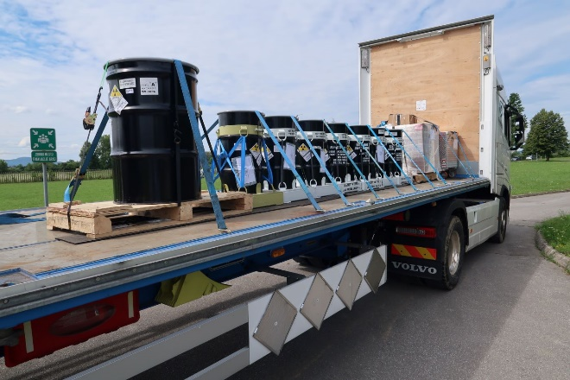

Figure 2: Cargo with Ra-226 sources being prepared for transportation. Author: ARAO

# The JEK2 project - New Nuclear Power Plant in Slovenia

The Government of the Republic of Slovenia continues to be active in the JEK2 project through a dedicated State Secretary to the Prime Minister’s cabinet that is responsible for coordination of different ministries and administrations in preparation for the project and the processes of licensing. A national strategic document, the *Resolution on the Long-Term Peaceful Use of Nuclear Energy in Slovenia* was adopted in the Parliament on 23 May 2024. Notably, the resolution underscores a commitment to high levels of nuclear and radiation safety.

A national advisory referendum planned for 24 November 2024 was cancelled right before the start of the referendum campaign due to certain concerns that there is not enough information available at present. However, the JEK2 project continues with preparation of studies and other documentation in support of the finalization of the National Spatial Plan and other required changes to the local infrastructure.

The process of preparing the National Spatial Plan may begin before the end of 2024. The initiative for the national spatial plan was revised according to the comments received from the ministries involved in the process of site selection and environmental impact assessment. The investor delivered the initiative to the Ministry of the environment, climate and energy (MECE) on 15 October 2024. Afterwards this ministry will submit the initiative to the Ministry of natural resources and spatial planning, responsible for the strategic spatial panning. Simultaneously, GEN energija d.o.o. is preparing the bidding documentation and held meetings with the three potential NPP vendors and local suppliers and subcontractors. Additionally, the investor is establishing the operational framework by recruiting new personnel and conducting training sessions. The MECE and the SNSA are also hiring new staff for the JEK2 project.

The SNSA is actively following the JEK2 project and recently issued new requirements for the new builds within two regulations defining the requirements on nuclear safety (see Chapters I.1 and I.2). Another important regulation for siting, namely the Decree on the areas of limited use of space due to a nuclear facility and the conditions of facility construction in these areas, is still in revision. Some relevant practical guidelines are being prepared or revised, e.g. on defining the contents of the Safety analysis report and on defining the siting process for new nuclear facility.

As part of the intense debate on possible expansion of Slovenian nuclear programme at the moment particularly in the context of the JEK2 project also the Director General of the International Atomic Energy Agency (IAEA) Rafael Mariano Grossi visited Slovenia at the invitation of Prime Minister Robert Golob. He participated in a panel discussion on the importance of nuclear energy attended by high-level representatives of the government, nuclear sector and civil society, and also the SNSA management. In addition, a roundtable held by the student councils of the University of Ljubljana was organised and finally he visited the Krško NPP.

# INTERNATIONAL COOPERATION

## Bilateral Relations

The traditional quadrilateral meeting of the nuclear regulatory bodies of the Czech Republic, Hungary, Slovakia, and Slovenia, which all have bilateral agreements with each other, joined by the regulators from Finland and Poland was this year hosted by Hungary on 14 and 15 May. The meeting with the main objective of sharing experience and informing each other of important developments in the field of nuclear safety included a broad discussion on the important aspects of the expansion of the nuclear programs in participating countries.

The 26th annual meeting under the bilateral agreement with Austria took place in Graz, Austria, on 8 and 9 October. The delegations discussed the most important events and developments since their last meeting in Ljubljana in 2023. The topics of discussion included the new developments in the regulatory infrastructure, radiation monitoring, emergency preparedness, radioactive waste treatment and management, operation of research reactors, the operation of the Krško NPP (regular outage, third periodic safety review, further actions after the unplanned shutdown in 2023) and activities on the JEK2 project.

Before the end of this year also the next, 13th annual meeting under the relevant bilateral agreement with Croatia is planned to be held on 19 December 2024 at the SNSA.

## Seventh European Conference on Nuclear Safety

The 7th biennial Nuclear Safety Conference under the auspices of the European Nuclear Safety Regulators Group (ENSREG) was chaired by the SNSA Director Mr Igor Sirc. The conference entitled *"Responding to the growing interest in nuclear energy"* took place in Brussels on 24 and 25 June and was attended by 214 participants. 31 diverse speakers addressed several actual topics, such as adaptation of nuclear regulatory processes for future challenges, recruiting and retaining qualified staff in the nuclear sector, addressing the challenge of climate change on the safety of nuclear facilities, and the regulatory approaches for licensing of small modular reactors. The participants emphasized several times that nuclear safety is an issue to be dealt with on an international and interdisciplinary level and open and transparent communication between regulators and stakeholders.

## SNSA Hosts EACA and ENSRA Annual Meetings

On 7 and 8 May, the annual meeting of the **European Association of Competent Authorities for Safe Transport of Radioactive Material** (EACA) was held in Ljubljana for the first time since Slovenia joined this association. The meeting was also attended by the regulatory bodies of several Mediterranean countries which are members of the so-called Mediterranean Region Transport Network (MedNet). The discussions included the following topics: validation and approvals, inspection practices of transport of radioactive material, radioactive sources in scrap metal and their return, shipments of large components, denials of shipments of radioactive material etc.

The annual meeting of the **European Nuclear Security Regulators Association** (ENSRA) took place on 25 and 26 September and was also hosted by Slovenia for the first time. Slovenia has been in the ENSRA’s chairing Troika since 2023, together with Switzerland (Chair) and France (Co-chair). The meeting agenda offered a string of interesting topics, including the members’ briefings on major national accomplishments in the sphere of nuclear security, co-operation of ENSRA with other partners and organisations as well as overviews of the recent work of three thematic working groups. Other important topics embraced the future work of the ENSRA and its next engagements.

# EMERGENCY PREPAREDNESS

## Exercises and Trainings

The first annual exercise of the Krško NPP, "NEK2024-1," was conducted in June. The aim of this unannounced exercise was to test the response time for activating the Emergency Response Team. The scenario assumed a total loss of electrical power, providing a critical test for the National Plan, which was used for the first time following its 2023 revision.

In September, the SNSA participated in the ECUREX 2024 exercise, which proved to be an excellent opportunity for a cross-border communication through the WebECURIE system in the event of a radiological or nuclear emergency.

Members of the SNSA Emergency Response Team also attended numerous training sessions, the most important was the training for communicators, which was crucial for improving both communication and coordination during emergency situations.

The lessons learned from recent exercises and the latest changes of the National Emergency Response Plan were incorporated in the recent revision of several SNSA emergency preparedness and response procedures.

## SNSA Emergency Preparedness and Response During the War in Ukraine

With two years having passed since the start of the armed conflict in Ukraine, the SNSA continues to closely monitor the conditions at the country's nuclear facilities.

## Other news

In September, the SNSA was notified through the Unified System for Information Exchange in Incidents and Emergencies (USIE) that trace amounts of Cs-137 were detected in Norway and Sweden. In response, the SNSA immediately ordered additional air radioactivity measurements across Slovenia to monitor any potential impacts and to track the levels and dispersion of radioactive substances in our country. The values measured showed no deviations from normal levels for Cs-137 or other radionuclides, confirming that there was no impact on the territory of Slovenia.

Map of Slovenia showing the positions of nuclear installations

Figure 3: Nuclear installations in Slovenia